EXP 2 : Covariance, Eigenvalues and Eigenvectors Analysis
PROGRAM:
import numpy as np
import matplotlib.pyplot as plt
x = np.array([2, 3, 4, 5, 6])
y = np.array([4, 5, 6, 8, 9])
data = np.vstack((x, y))
cov = np.cov(data)
print("Covariance Matrix:")
print(cov)
values, vectors = np.linalg.eig(cov)
print("\nEigenvalues:")
print(values)
print("\nEigenvectors:")
print(vectors)
plt.scatter(x, y, label="Data Points")
mean = np.mean(data, axis=1)
for i in range(len(values)):
vector = vectors[:, i] * np.sqrt(values[i]) * 2
plt.quiver(mean[0], mean[1], vector[0], vector[1],
angles='xy', scale_units='xy', scale=1,
label=f"Eigenvector {i+1}")

plt.title("Covariance, Eigenvalues and Eigenvectors")
plt.xlabel("X Values")
plt.ylabel("Y Values")
plt.legend()
plt.grid()
plt.show()
OUTPUT:
Covariance Matrix:
[[2.5 3.25]
[3.25 4.3 ]]
Eigenvalues:
[0.02768625 6.77231375]
Eigenvectors:
[[-0.79588915 -0.60544237]
[ 0.60544237 -0.79588915]]

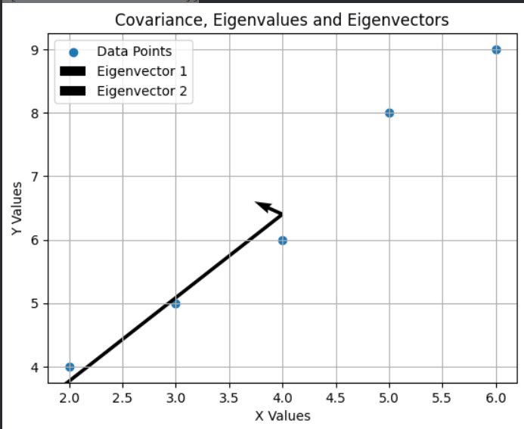

Result
Thus, the covariance matrix, eigenvalues, and eigenvectors are calculated, and the data points with eigenvector directions are visualized using Matplotlib.

